**Home**

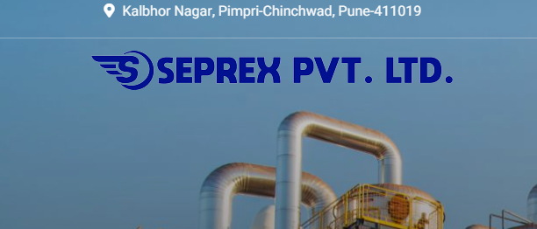

1. Remove PVT LTD, keep Logo and Seprex Only. DONE
2. Remove Address



1. BROCHURE option instead of Get an Estimate DONE

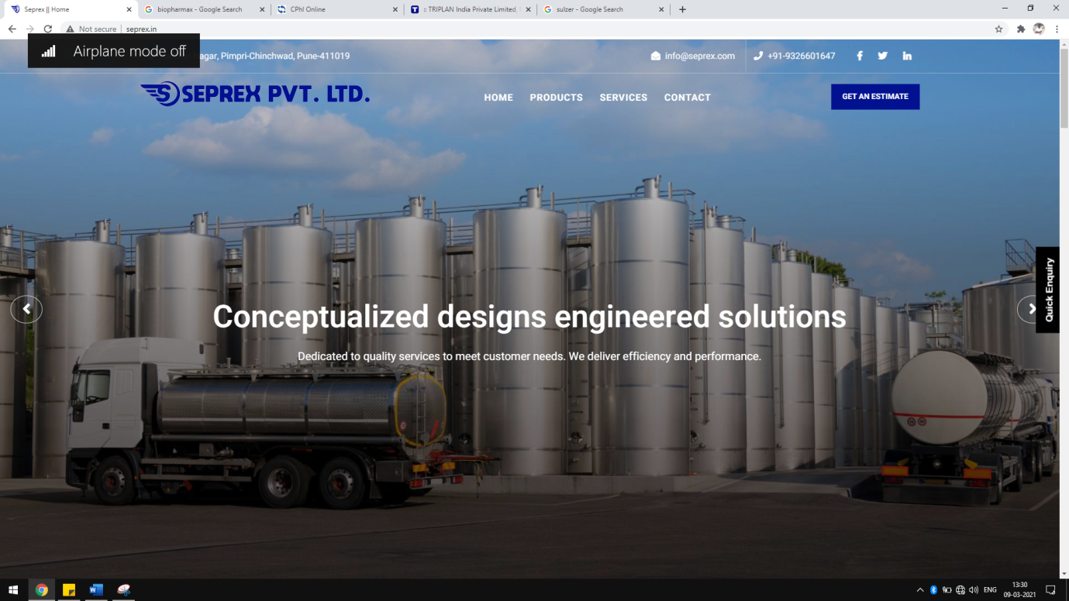

1. All images should be placed, right now only 2 images are shifting Done
2. Increase the brightness in marked area for all images on homepage Done
3. Remove the line presented in yellow box Done
4. Remove the address in green box Done

Please mentioned following tag lines with images Done

**SEPREX – EXPERTS IN SEPARATIONS AND REACTIONS TECHNOLOGIES -**

One Stop Solution Company

Excellent Engineering Products

Committed to Deliver Excellence

Turnkey Solutions – From Conceptualization to Commissioning

Social Media Links – Done

LinkedIn <https://www.linkedin.com/company/seprex-pvt-ltd/>

Facebook <https://www.facebook.com/SeparationAndReaction/>

YouTube <https://www.youtube.com/channel/UCcaD2joQxmr9c6YcHdhzS9g/featured>

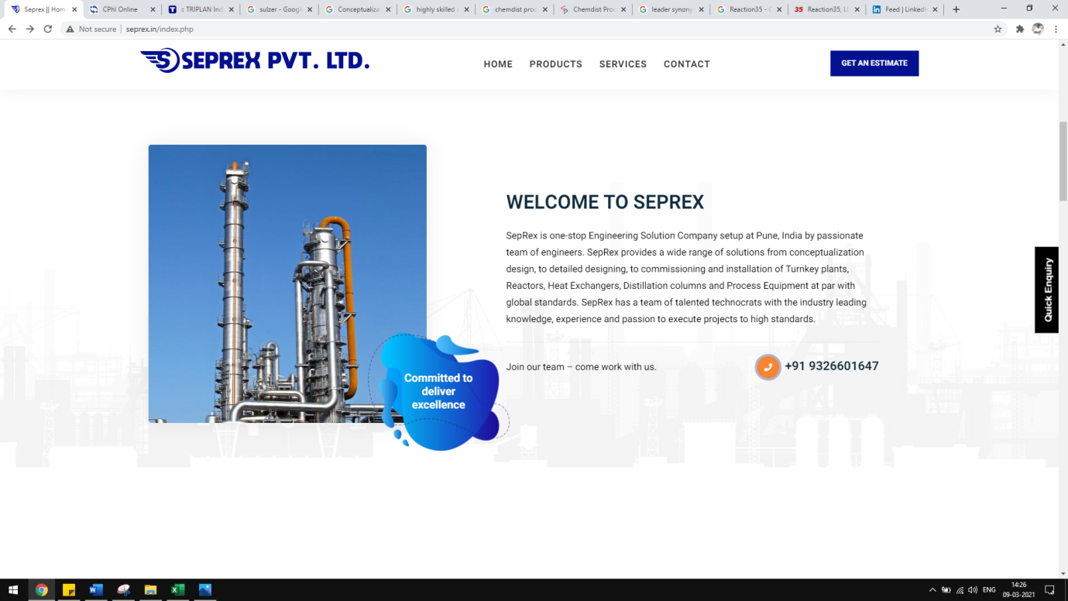

1. Please remove the shape marked in orange box and alter with another decent shape
2. Remove Phone number and Join our team Done
3. Image marked in yellow box should utilize the page area, also increase the font according keep text justified.
4. **Minimize the empty space Done**

**Products**

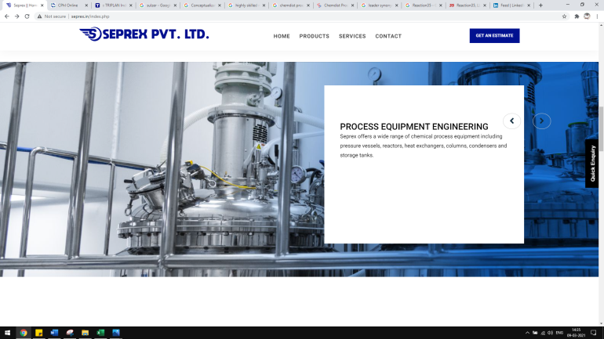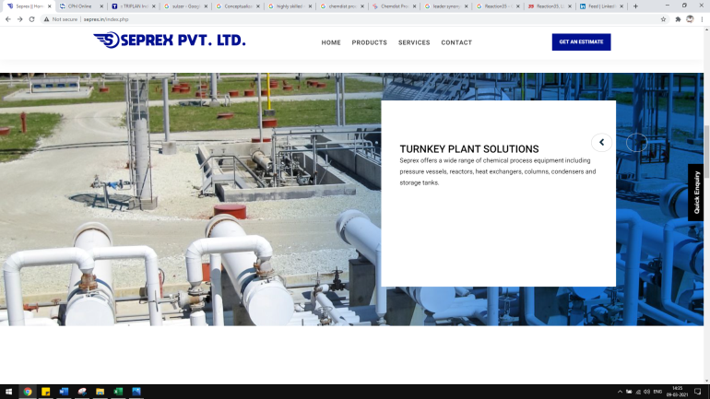

1. Reduce the flash time Done
2. Product Description box should be transparent marked with yellow color Done

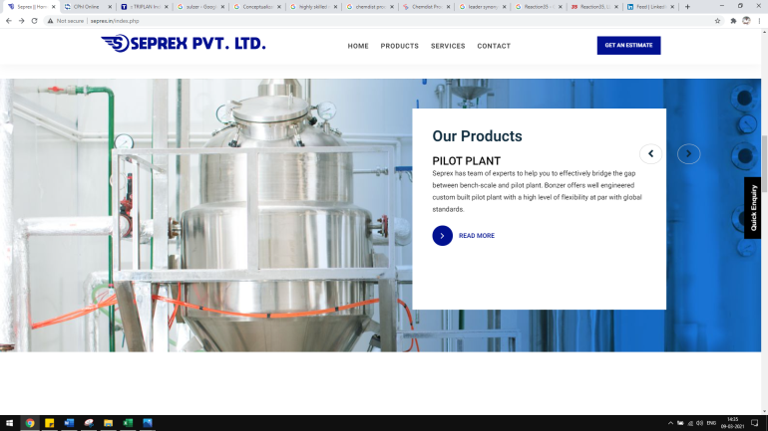

**Services**

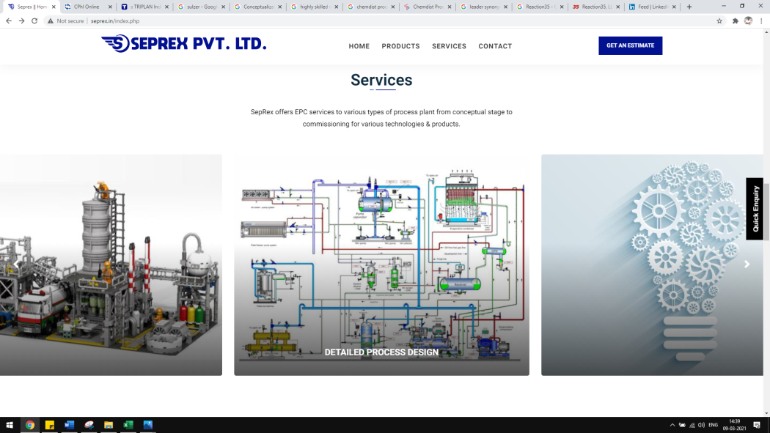

1. Follow same pattern of Product page for Services Done

**Advisory Board**

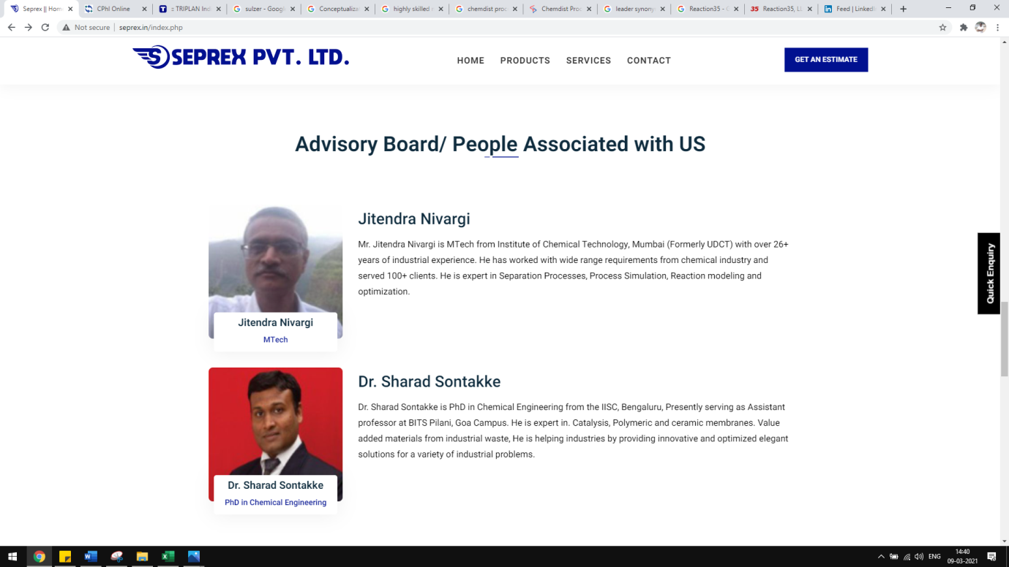

Keep ADVISORY BOARD only Done

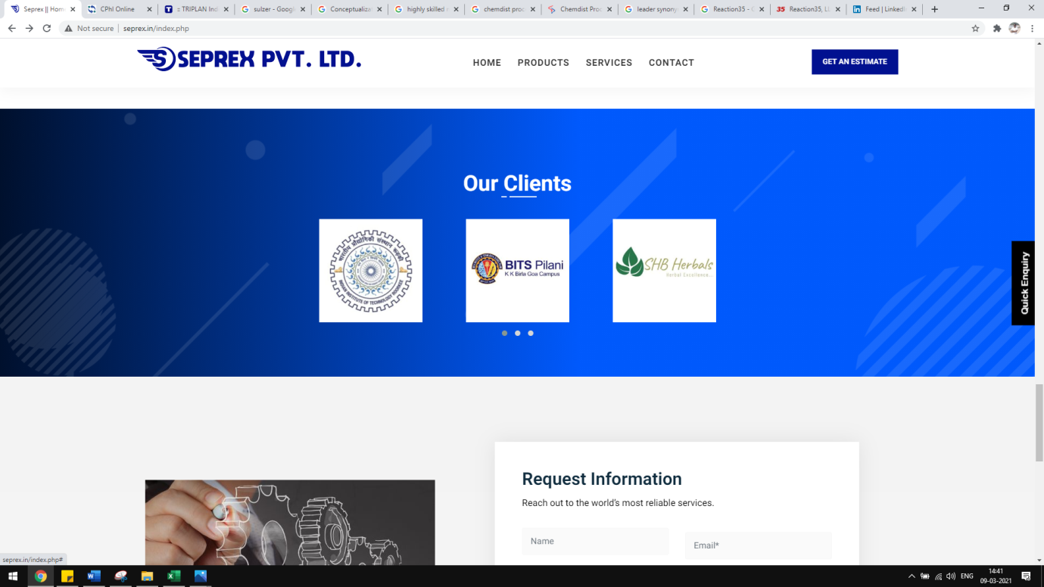

Reduce Flash Time Done

Please keep white background for logo. Done

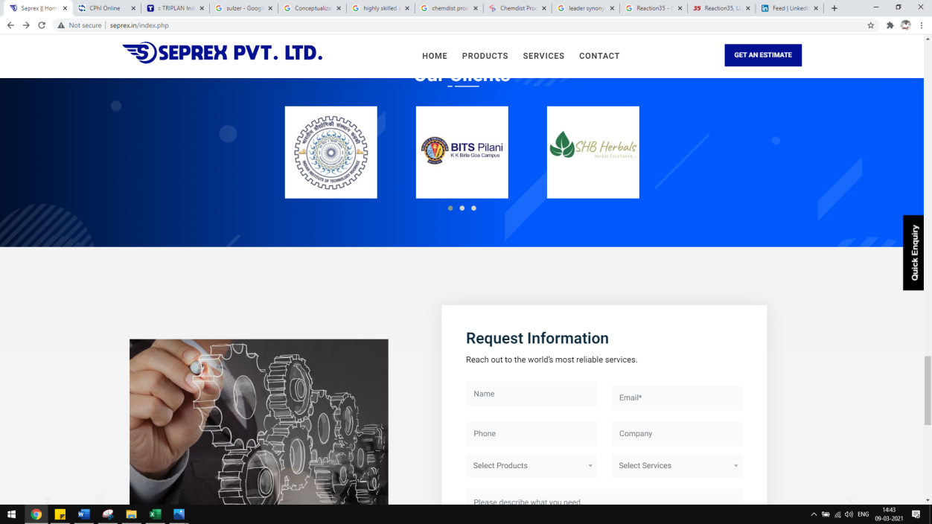

Please keep our clients and Request information on single page Done

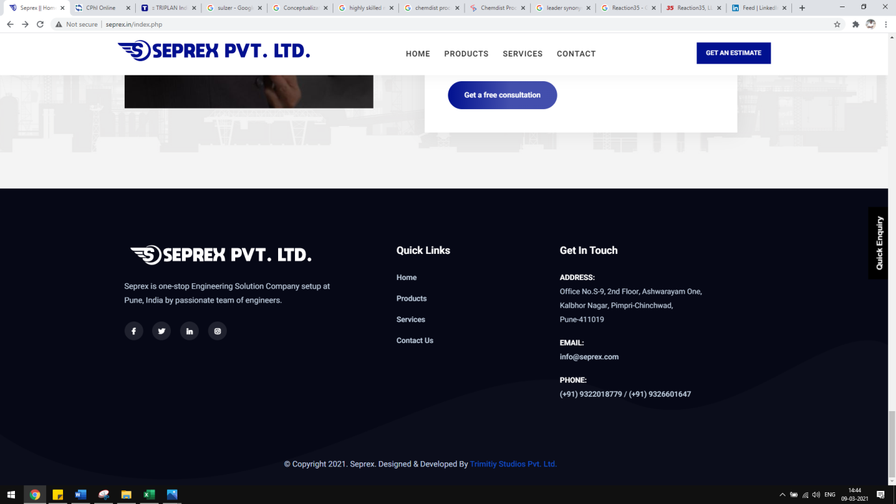

Reduce the size of information page Done

**OUR PRODUCTS –Make same as below Reference, keep Our Products at Centre**

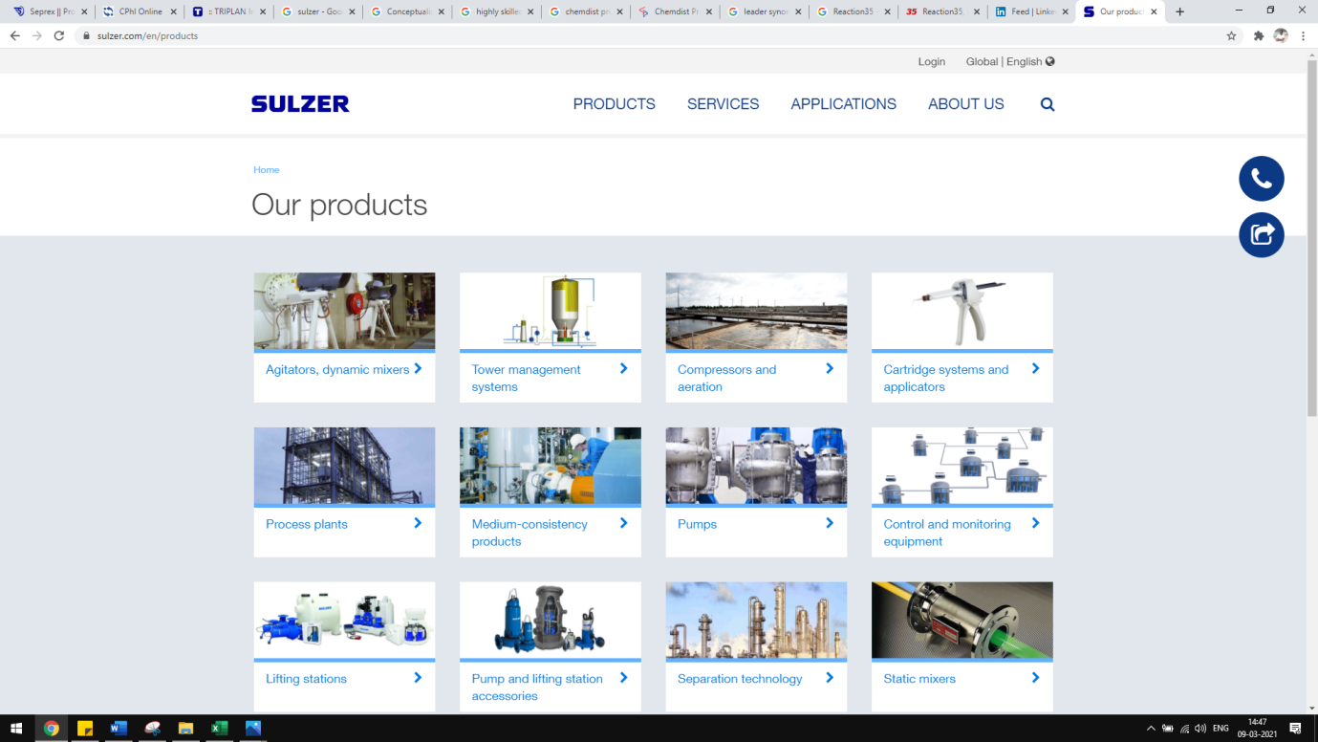

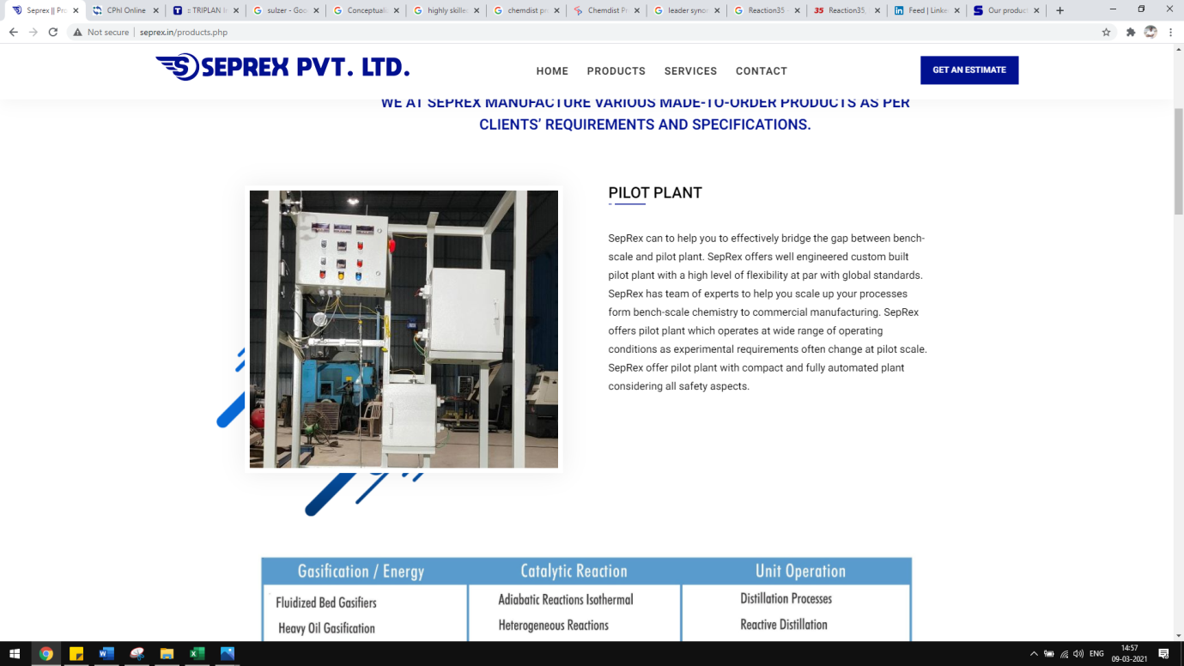

1. **Minimize the empty space Done**

Change the below table design, please don’t copy paste from old brochure. Need this table in word format

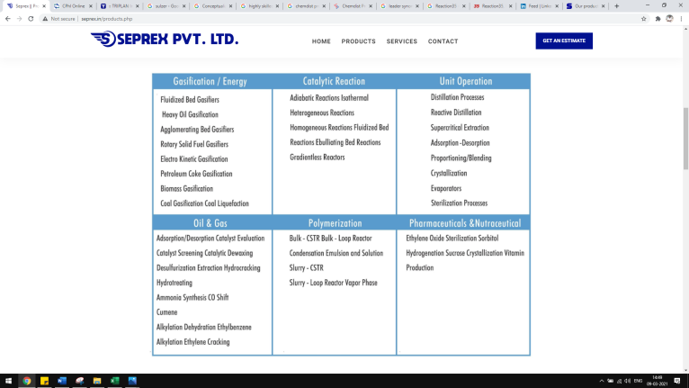

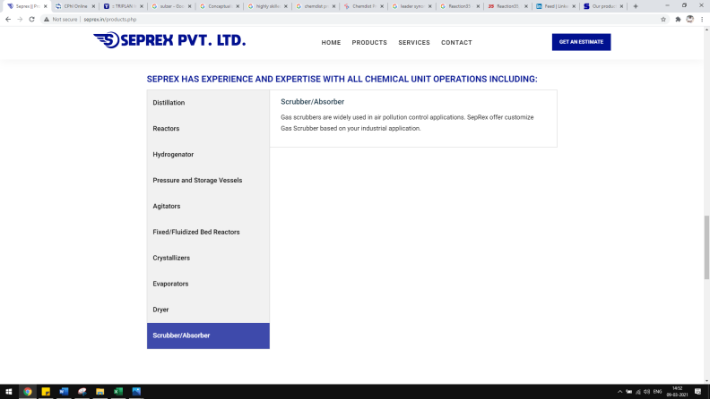

1. Add following product Done
   1. Bioreactor/Fermenter/CIP Skids

We manufacture bioreactors, fermenters and CIP/SIP systems for R&D, and industry for fermentation, cell culture, stem cells, renewable technologies, algae, biomass, biofuel, hydrolysis applications.

1. Use following design to show EXPERIENCE AND EXPERTISE

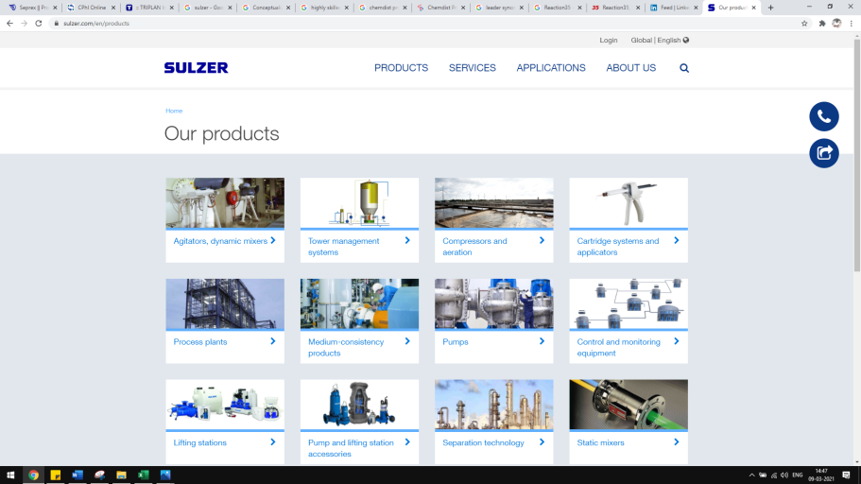



Logo lost its round shape please revise, remove 2 vertical lines

Seprex - SEPREX Done

**SERVICES**

**Use same design suggested for Products Done**

* **Resize images with proper sizes before placing on the website, currently images are not completely visible**

**Locations**

**OFFICE ADDRESS – Done**

Office No.S-9, 2nd Floor, Aishwaryam One,  
Kalbhor Nagar, Pimpri-Chinchwad,  
Pune-411019

**WORKSHOP ADDRESS – Done**

Plot no A22 Gut no 1325

Sononewasti Chikhali

Beyond Hindustan weigh bridge

USE WORKSHOP PHOTO PROVIDED BELOW

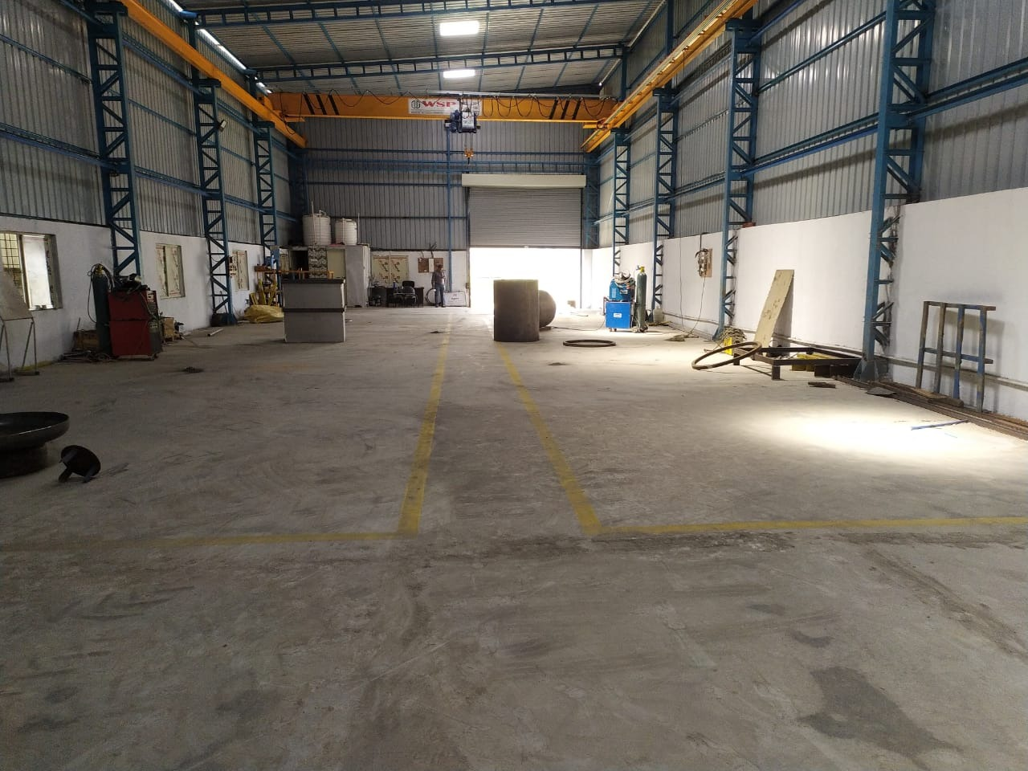

Manufacturing Facility: **Done**

Crane - 5 Ton

Tig Welding Machine – 3 Nos

Lathe Machine – 2 Nos X 5-meter bed

Change Google Location w.r.t. address.